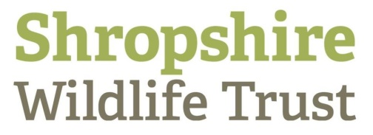

Dear xxxxxx

As your local Wildlife Trust, we work on the ground to protect and recover nature in the xxxx Constituency. We manage 1000 Hectares with over 40 Nature Reserves for wildlife and the enjoyment of people, with the support of more than 600 regular volunteers and 11,500 members. Collectively, the Wildlife Trust movement has over 800,000 members and 43,000 volunteers.

The upcoming General Election is a crucial moment for wildlife in the UK. Our natural environment is in crisis – the UK is one of the most nature-depleted places on earth and over half of our wildlife species are in decline.

We are utterly dependent on nature for our wellbeing and prosperity, so it is vital that the next government enacts the kinds of ambitious measures that will guarantee wildlife’s recovery. There is evidently widespread support among the public for such decisive action.

Shropshire Wildlife Trust believes that there are serious environmental pressures that it will need to urgently address:

- The climate crisis is upon us. We demand this is treated as the most pressing emergency facing the whole of humankind
- A new Environment Act is needed to halt the continued and catastrophic loss of wildlife. This needs to be adequately resourced and regulated
- Declining physical and mental health is exacerbated by poor public connection to the natural world. All new development must include high quality, accessible greenspace

Our members would be very interested to know what you will do for wildlife in Shropshire and across the country. I would be grateful if you could respond to the following questions:

- How will you and your party act decisively to tackle the crises in the natural environment?
- What will you do to ensure we have farming policies that support land managers in contributing to nature’s recovery?
- What will you do to ensure that proposed development supports high quality, publicly accessible greenspace?
We are asking all candidates in Shropshire these questions. If you have no objections, we will share your responses with our members and publish them on our website along with those from other candidates.

I look forward to hearing from you.

Colin Preston
CEO
Shropshire Wildlife Trust
Shropshire Wildlife Trust is a registered charity number 212744
Company number 729 746
193 Abbey Foregate, Shrewsbury, SY2 6AH

