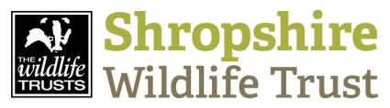 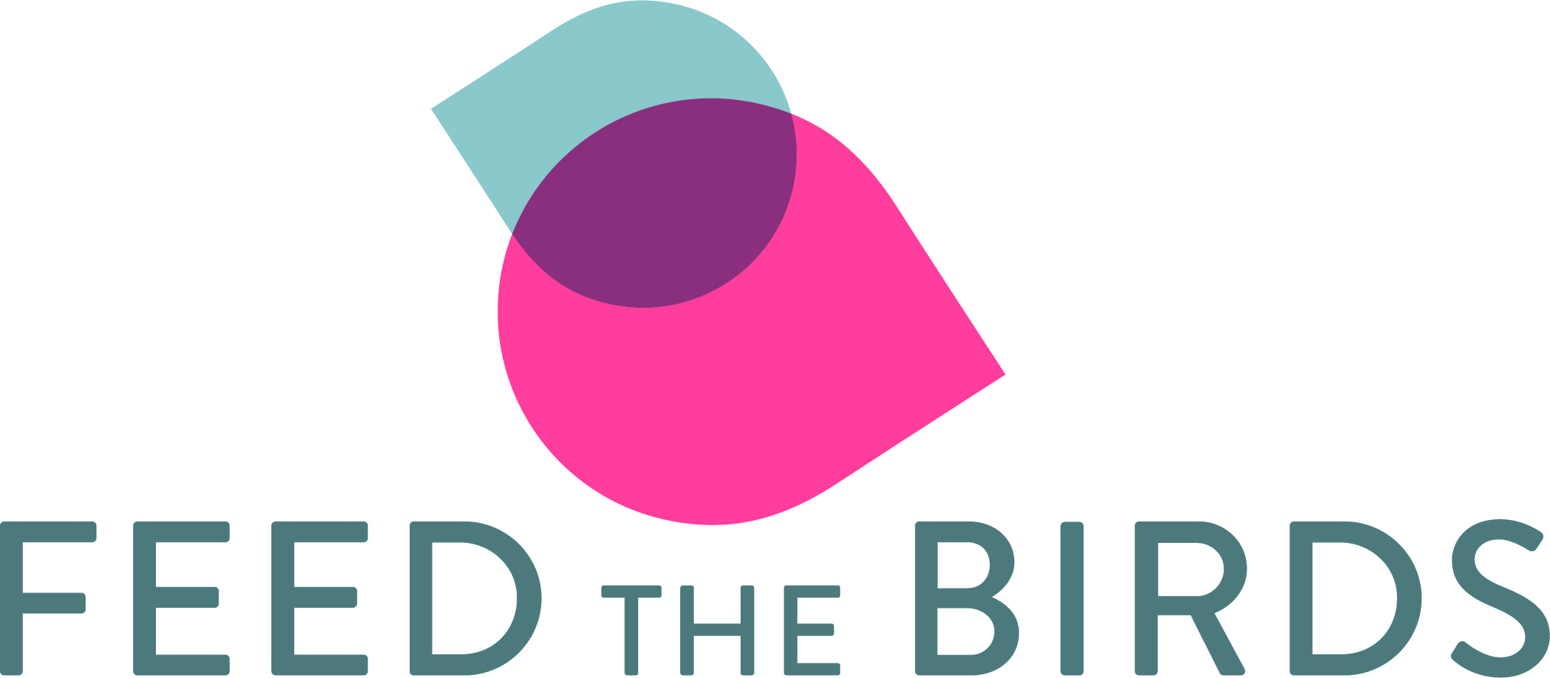 volunteer
Team
People and Wildlife
Role description

This role is part of our Feed the Birds project. Volunteers are matched with prospective clients who are assessed as lonely or socially isolated. The clients are referred by a range of organisations and agencies across Shropshire. The role entails a weekly visit at fixed, agreed times for an hour. The clients will be provided with feeders and food and the volunteer’s role is to visit and help fill the feeders, chat with the client about what they have seen and make some brief notes about their observations of the person’s wellbeing. Any undue concerns are to be raised directly with the referring agency and support will be provided by the Feed the Birds project officer. Volunteers will be matched with a client living within reasonable walking, cycling, bus or driving distance and travel costs can be claimed. Claims are to be submitted monthly. Volunteers will not be asked to handle money other than collecting donations in a sealed pot. You should not carry out any additional tasks other than that of the Feed the Birds role.
Commitment required:
- One day training which will include a project overview as well as personal safety, listening skills, confidentiality and cultural awareness, sexual identity and discrimination plus the practicalities of bird feeding. Coco trained volunteers can be fast-tracked and just need to do a half day training. Contact the Feed the Birds officer to find out more.
- Attendance at a Shropshire Wildlife Trust ‘Find out about Volunteering ‘session. These take place quarterly at The Cut, Shrewsbury and last approximately an hour.
- Participation in evaluation of the project – this will take the form of short questionnaires for both you and your client. Training and support will be given for this important element of the role
- Quarterly Supervision meetings are held at The Cut, Shrewsbury and last approximately 2 hours. All volunteers are expected to attend. These meetings provide an important opportunity to share experience and raise any issues with staff & volunteers and to monitor and check progress and we often invite a speaker or do an activity relevant to the project
- Two satisfactory references and a DBS check are required for this role.
- Feed the Birds volunteers will also be required to complete a half day Adult Safeguarding course before starting. This course is run by Joint Training at various venues across Shropshire

Existing experience & qualities | Essential or desirable
Listening / empathic hearing  Interest in birds and bird feeding  Open minded / non judgemental  Dealing with vulnerable people  Basic bird ID skills  commitment to the project | Essential  Essential  Essential  Desirable  Desirable  Essential
Skills development offered

- One day Training is part of the requirement and this includes: Communication and listening skills, boundaries and confidentiality, understanding bereavement, sexuality and cultural awareness plus practical training in use of bird feeders and bird food, bird ID skills, dementia awareness
- You will be working as a team on a project within a large county- based environmental charity
Support available

- Quarterly supervision meetings which will be held at The Cut Visitor Centre, Shrewsbury, plus staff support as and when needed.

Minimum time commitment needed

One visit per week lasting up to an hour Monday to Friday for 6 months minimum plus one-day training and quarterly supervision meetings which last 2 hours. Training and supervision is based in Shrewsbury. Travel costs can be claimed for the training and supervision meetings.
Other information
- You will be expected to comply with safeguarding policy and procedures and code of practise for appropriate behaviour. Satisfactory references and a DBS check are part of the recruitment process. You’ll be signed up as a volunteer and receive our quarterly newsletter plus invitations to social events and training.
Contact
Diane Monether Feed the Birds project officer 01743 284271 dianem@shropshirewildlifetrust.org.uk

