Make a Simple Bird Feeder

Make a home-made bird feeder to attract birds to your garden. Not only will they benefit from the extra food when it’s cold, but you’ll be able to see them much more easily too.
Make your bird feed by mixing one part lard with two parts bird seed. You can also add in oat flakes, raisins, sultanas, currants, unsalted peanuts or grated cheese, but make sure you keep the ratio the same – half as much lard as everything else. | 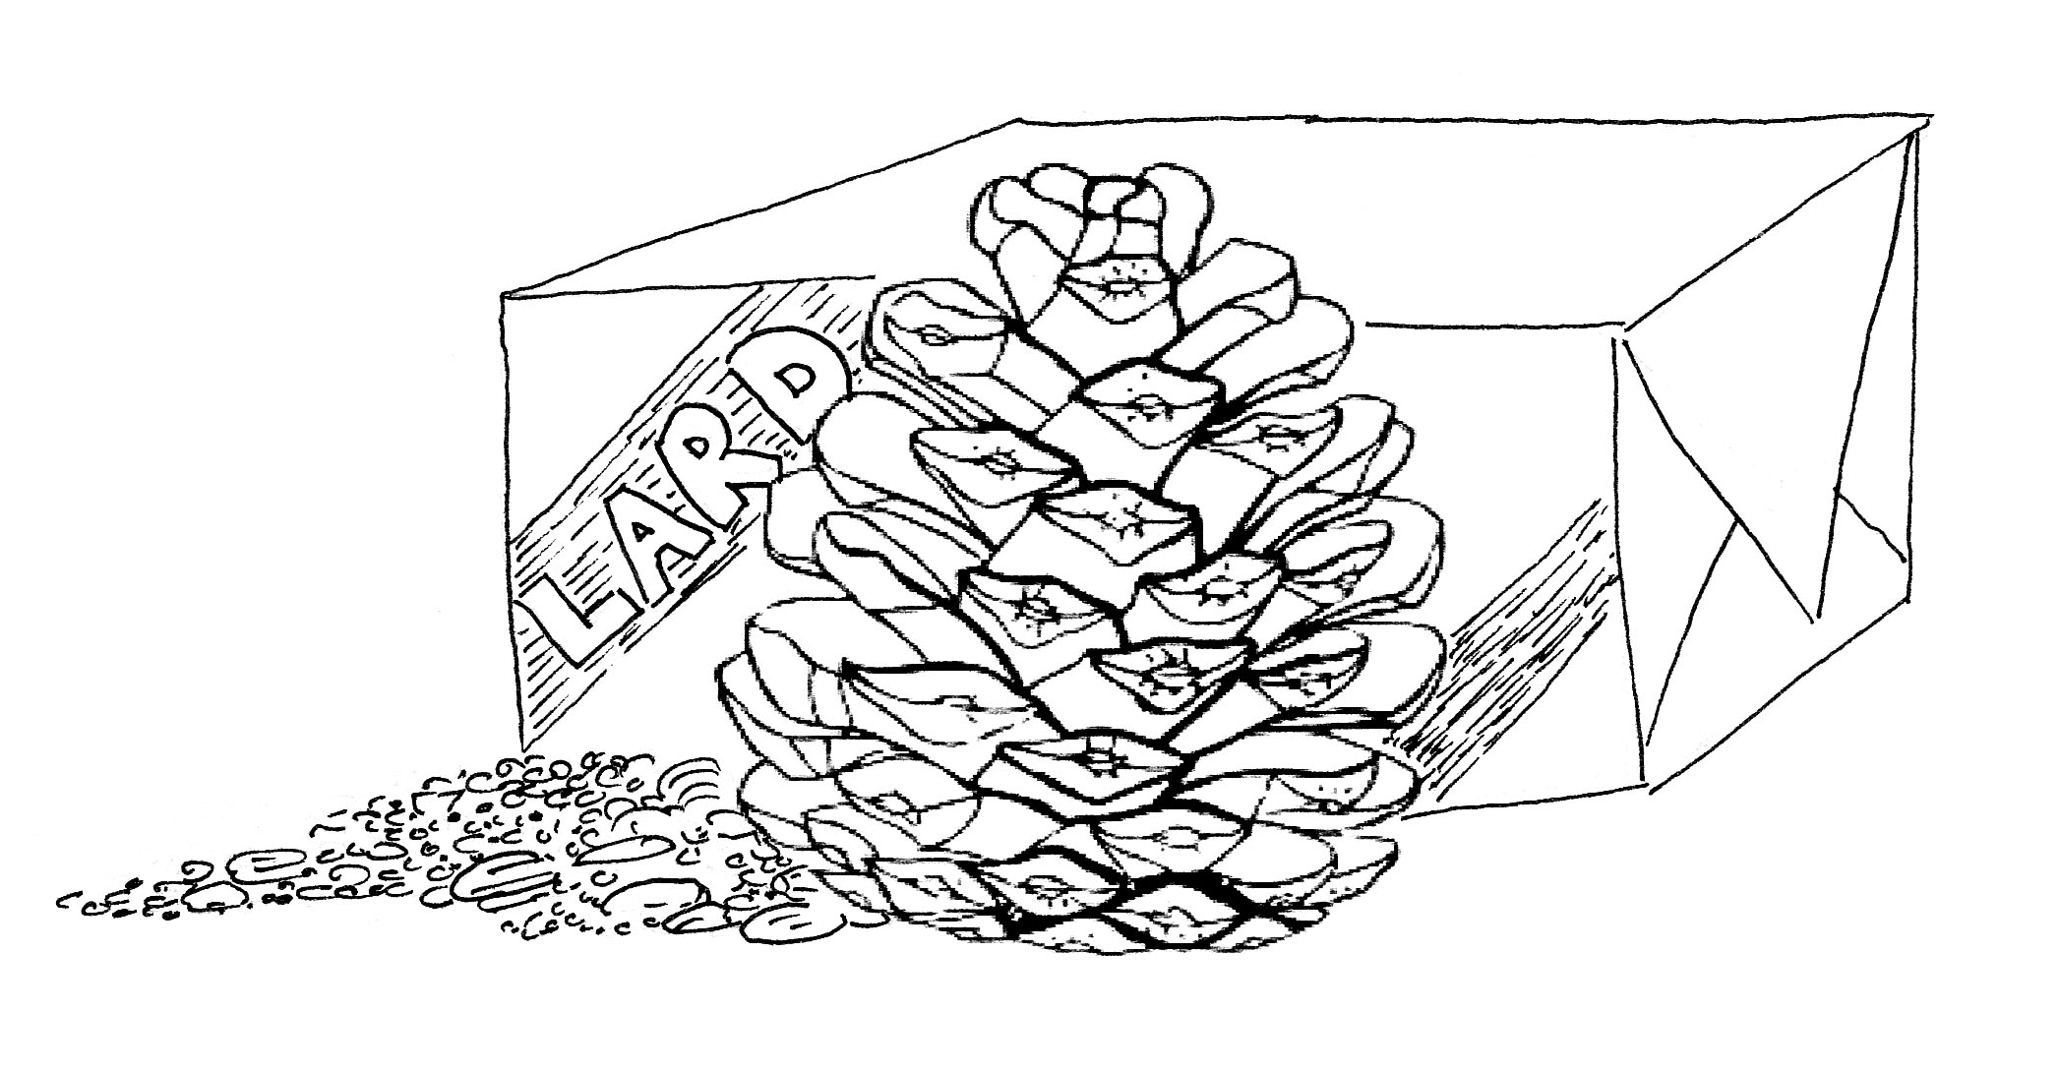
You can use a spoon or get stuck in and squish it all together with your hands, or you could whizz it all up in a food processor instead. Do not melt the lard but have it at room temperature so it’s easy to combine with the seeds.
Take a large pine cone and tie a string to the pointed end to hang it up. Squish the bird feed into the cone, making sure it goes into all the nooks and crannies.
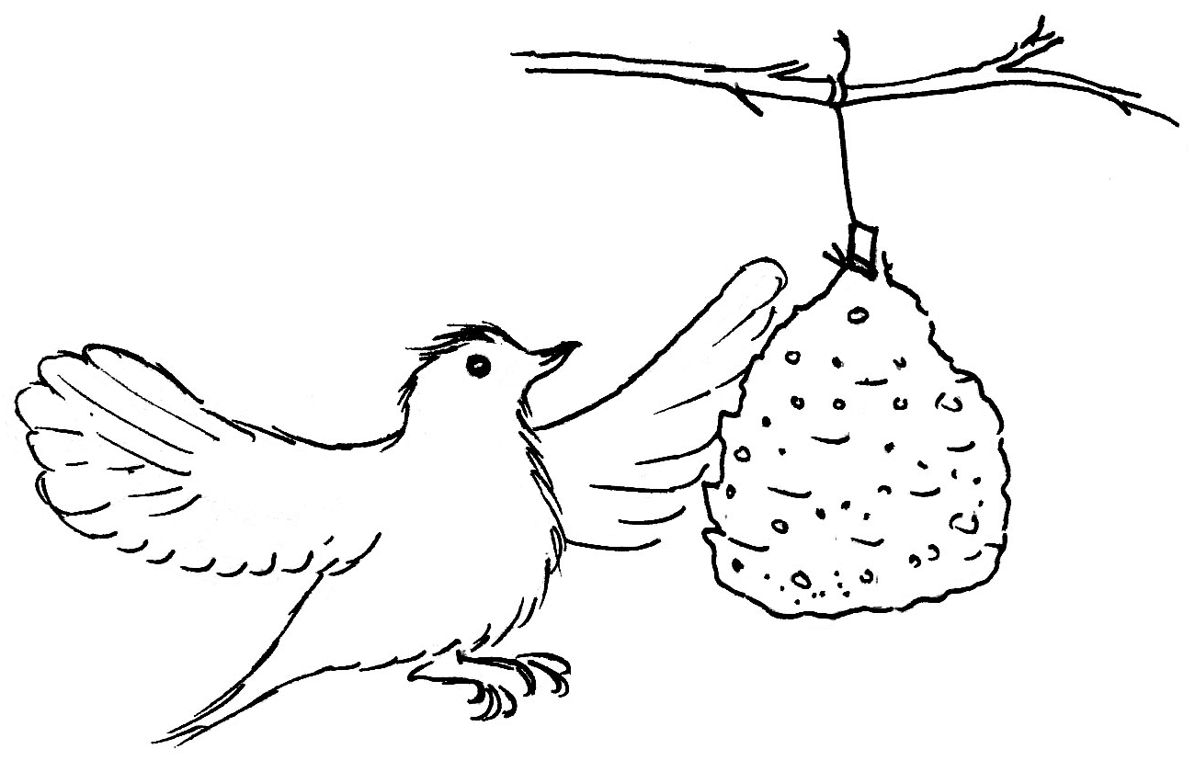 |  | It really is easiest to do it with your hands, even though you’ll get very messy.  Put your pine cone feeder(s) in the fridge for an hour or so to harden up before you hang them up for the birds.

