Make a Winter Home for Bugs

Bugs need somewhere safe to spend the winter. Make a simple bug house to give them shelter in the cold months
Make a tube of chicken wire about 30cm long and 15cm in diameter. Twist the wire ends round each other to secure it.  Push sticks crossways through one end of the tube to make the ground floor.  Push more sticks, leaves, bits of bark and fir cones down the tube to fill it completely. |  | 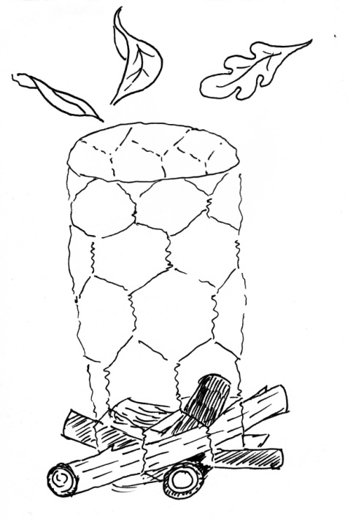
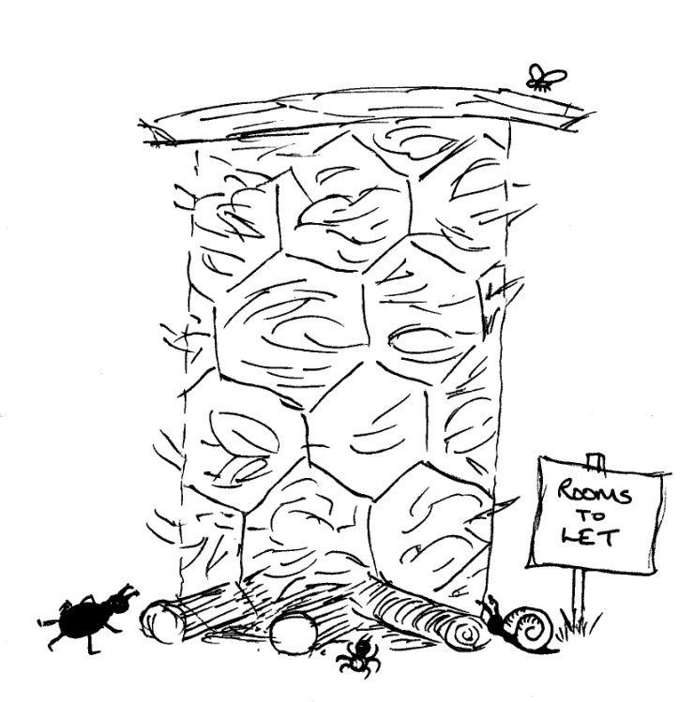 | Put a flat piece of wood or bark on the top to make a roof to keep it dry.  Place your bug house in a sheltered place by a hedge or tree. You might need to tie it to the tree trunk to keep it secure and upright.  As the filling rots down, add more material from the top.

