Press some Autumn Leaves

Get out on a cold autumn morning and collect some lovely coloured autumn leaves. Choose the best ones to press. How many different shapes can you find?
Use a flower press if you have one, or cut some sheets of newspaper or blotting paper and pieces of card the same size as a large heavy book.
Put a sheet of paper on the piece of card, and arrange your leaves flat on it, so none of them touch each other, and cover them with another sheet of paper. Lay a piece of card on top, and another sheet of paper.
Put more leaves on this sheet, and cover it with another sheet, and so on until you’ve used all your leaves.
Put the whole stack carefully somewhere, where you can leave them undisturbed, and put the book on top. Be patient, and don’t disturb it for two or three weeks, until the leaves are dry.

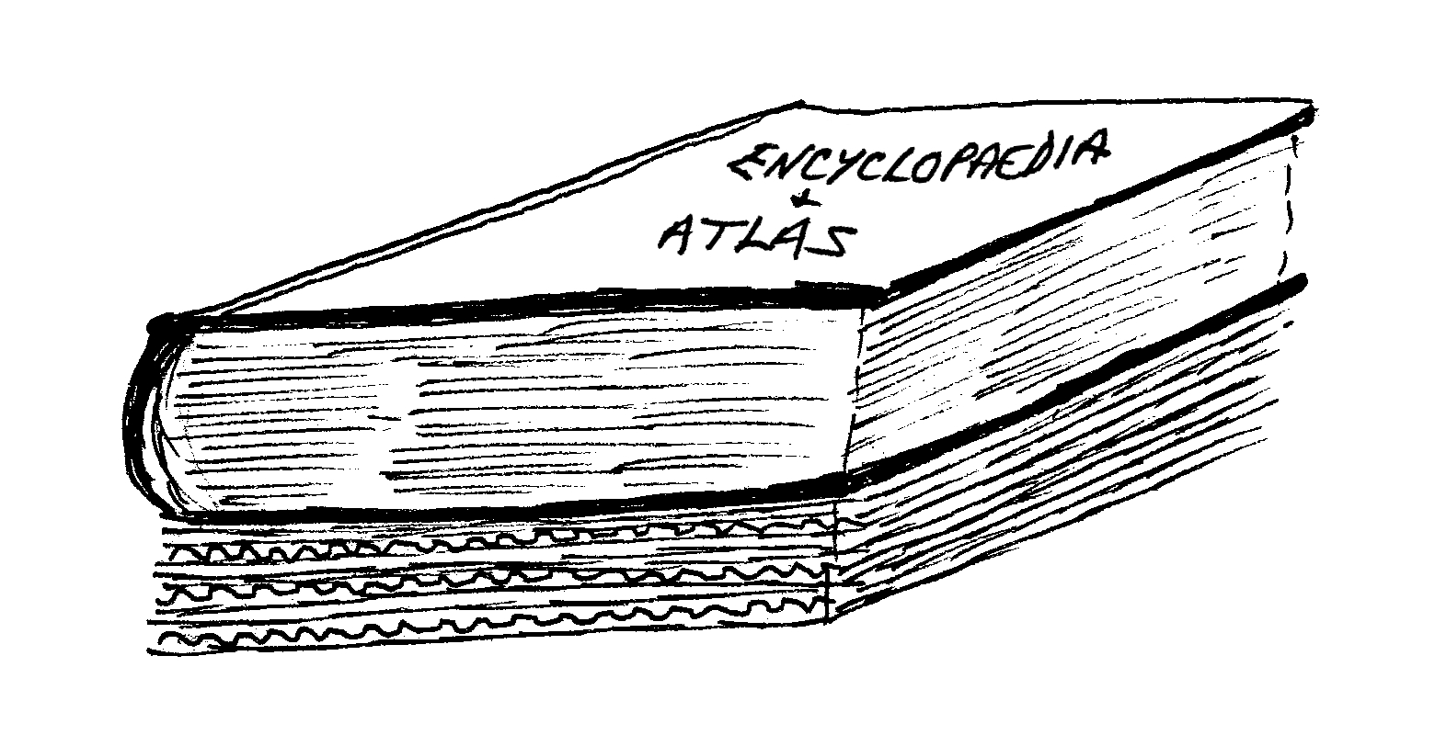 | You can use your pressed leaves to make a collage – perhaps a calendar or a cover for a scrap book, a picture for the wall, or you might have a better idea yourself.  Arrange them carefully before sticking them down with a dab of glue stick, and cover the whole thing with transparent sticky-backed plastic to stop the leaves turning brown.

