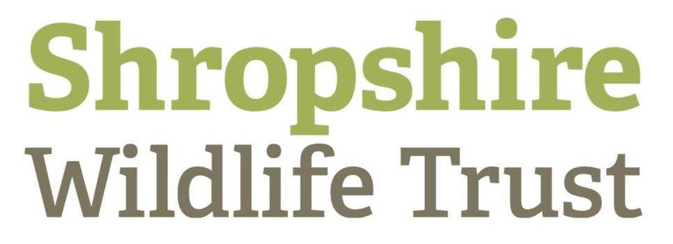

Agricultural Advisor

ST/WT Catchment Partnership

For Teme Catchment

Full Time: Fixed term contract till end of March 2022

Accountable to: SWT River Projects Manager Pete Lambert and ST Agricultural Team Manager Emma Abbott

The post-holder will be a member of the Rivers Team at Shropshire Wildlife Trust

Objective of the job

Severn Trent Water [STW] and the West Midlands Wildlife Trusts are working with the Environment Agency and other partners on river catchments to tackle diffuse water pollution in watercourses across the region and to bring watercourses into ‘good ecological condition’.

Over the last five years, Severn Trent have developed a programme of catchment management schemes across 44 catchments. These schemes aim to halt and reverse the rising trend of nitrate and pesticide levels in raw water and promote biodiversity on farms. The successful candidate will join an existing catchment management and biodiversity team whose purpose is to enhance biodiversity and help farmers reduce the levels of nitrate and pesticides entering the water environment close to our water supply sources.

An important part of this programme is to work with farmers and landowners to reduce diffuse agricultural pollution into rivers and streams and protect water quality in relation to the provision of drinking water from groundwater sources, support and promote wildlife of the farmed environment.

The post has been designed to deliver a programme of advice, training and grants to farmers and land managers to reduce diffuse water pollution in the Severn Trent Teme priority catchment which covers the Shropshire and Worcestershire county. This programme aims to reduce pesticide and nutrient concentrations in surface water with farmers on a voluntary basis, bring added biodiversity value to their farms and provide farm wildlife a boost.

Key results expected

The post-holder will deliver a programme of farmer/agronomist training events, one to one farm visits to promote resource protection, habitat creation and a reduction in diffuse water pollution from agriculture, with a focus on pesticides.

The post-holder will aim to raise awareness, improve understanding and acceptance amongst farmers and land managers of diffuse pollution from agriculture and its impact on water quality and the wider water environment.

Engagement with farmers in targeted areas identified by STW will seek to create through a voluntary approach, a sense of ownership and achievement within the farming community in relation to water quality in the catchment.

Severn Trent Environmental Protection Scheme [STEPS]

The post-holder will promote, engage and support farmer uptake of the Severn Trent Water capital grant scheme [STEPS] within the Teme catchment where pesticides and phosphates are a water quality risk. The STEPS scheme aids to support farmers in making farm infrastructure and land management changes to reduce diffuse water pollution. The STEPS programme also includes biodiversity options including:

- Wildflower meadow creation or enhancement
- Feeding farmland birds
- Herbal leys
- Beetle banks
- Biodiversity innovation

A key element of the role will be building positive relationships and supporting farmers to take up the STEPS options which will improve the water quality of the catchments by advising on priority land management measures to address the water quality risks present as well as advising on biodiversity options for the benefit of farmland wildlife.

Seven Trent’s programmes are evaluated using Key Performance Indicators – these are:
- Farm infrastructural and land management interventions resulting in load reduction of pesticides, nitrate and cryptosporidium to Severn Trent drinking water sources.
- Working with farming customers to deliver habitat and biodiversity improvements through Severn Trent’s biodiversity grant programmes.
- Overall farmer engagement in priority catchments
- Positive farmer engagement in priority catchments
- Improved knowledge/awareness of water quality issues within priority catchments
- Farm advice delivery through a range of on farm visits, workshops, farm demonstrations and events

Key tasks

The post-holder will be required to carry out the following tasks to meet the requirements of the role:

- Undertaking direct delivery of advice to farmers, influencing farmers to make behavioural and management changes on their farms.
- Provide advice and support on the Severn Trent catchment schemes
- To promote and seek farmer participation and sign up to the Severn Trent Farm To Tap scheme
- Promote, engage and seek participation in the STEPS programme and encourage farmers to apply for the priority water quality STEPS options to help reduce the water quality risk of pesticides within the Teme catchment
- Administer and verify scheme activity
- Maintain simple system of evaluation and feedback from farmers and land managers.
- Co-ordinate, deliver and participate in events to help with the promotion and awareness raising of the core messages and catchment management programmes
- Liaising with agricultural specialists, contractors and agronomists to ensure delivery of catchment action plan.
- To carry out in catchment water quality sampling as and when required
- To carry out in catchment water quality investigations when required.
- Plan and deliver training events, sessions and develop partnerships to meet local training needs in relation to water quality
- Prepare and submit monthly progress reports to ensure adequate monitoring of the programme, engagement activity and scheme take up into a Farmer Engagement Database.
- Contribute to annual reporting schedules
- Participate in relevant and complementary Wildlife Trust water environment initiatives, programmes and projects during the period of the contract in the context of the Catchment Based Approach and CABA Partnerships. This work will involve the development of new funding bids, delivery of wildlife projects [habitat and species] and taking in part in the campaigning and wider work of the Trust’s Rivers Team.
- Participate in relevant partner activities where these are complimentary to the core programme, assist in the development of water environment focussed projects in target areas and participate in Catchment Partnership activity appropriate to the catchments being targeted.

Core skills

You will be expected to have:

- Relevant environmental qualification/s in a land and water management subject
- Relevant professional qualifications in relation to providing agricultural sector advice – for example BASIS, FACTS or other CPD activities.
- Preferably a minimum of two years’ experience of providing pollution reduction advice to farmers and landowners
- A strong background in understanding water quality issues
- Have a sound understanding of lowland farming systems, wetland ecology, rural sustainable drainage and catchment management.
- Knowledge of the farmed environment and biodiversity
- Computer literate in MS Office with GIS mapping experience
- A Full Driving Licence and your own vehicle

Some weekend, Bank Holiday and evening working will also be required.

This post is suited to someone who is able to communicate technical information in a straightforward and accessible manner to a broad range of participants. They will be able to inspire and enable partners and stakeholders to take an active part in their water environment. They will be able to negotiate effectively with farmers and landowners and provide tactful and effective support to engage and meet programme targets.

The post-holder will be expected to conform to individual Wildlife Trust policy, employment practices and professional standards in line with national and legal expectations and requirements.

Nature Recovery Network & working relationships

All the Shropshire Wildlife Trust’s work is helping to deliver a Nature Recovery Network across Shropshire and Telford – this is the name we give to our approach to restoring and reconnecting large areas of habitat to allow wildlife to adapt to climate change and other environmental challenges. The River Recovery Network is the water and river catchment system component of the Nature Recovery Network. The programme delivery of the Wildlife and Farming Officer fits within a very broad range of activities all aiming to make a positive contribution to the future health and ecological condition of the water environment. The post-holder will be a member of the Rivers Team whose task it is to deliver on the vision of the River Recovery Network.

Job description created/reviewed PL/EA date

Agricultural Advisor – ST WT Catchment Partnership

Salary: | In the range £ 27,540 per annum + pension contribution (see below). Each post will be reviewed annually, following this review the manager or the member of staff may initiate a salary bid in recognition of high performance. Cost of living awards are normally awarded annually with effect from 1 April subject to the employer’s ability to pay.
Hours: | Full time. The nature of the post’s duties may from time-to-time require evening and weekend work. Paid overtime is not available, but time off in lieu of hours worked will be given, if requested.
Pre employment checks: | The post does not require a DBS check. The successful applicant will need to provide proof of right to work in the UK,
Probationary period: | All Trust appointments are subject to the satisfactory completion of a probationary service of six months.
Contract | Initially a fixed term contract available from 1st April 2021 until 31 March 2022 with the possibility of an extension
Holidays: | A full-time member of staff has 20 working days per annum in addition to 8 normal public holidays. An additional day is added for each year’s service up to a maximum total of 25 days holiday
Pension: | After three months the employee will be eligible to join the Trust’s group personal pension scheme and if they pay a minimum of 3% of salary the Trust will contribute 7% of salary to this scheme.
Notice Period: | During your probationary period, the period of notice for termination of your employment will be one week on either side. After successful completion of your probationary period the minimum period of notice is four weeks on either side.
Place of Work: | The post will be based Shropshire Wildlife Trust. 193 Abbey Foregate, Shrewsbury. Most Rivers Team members work out of home and office.
Home working | Home working Is available. IT kit is provided.
Travel: | Pool vehicles are normally available but the use of your own vehicle may be necessary at times. You are required to have insurance to cover business use and a mileage allowance of 45p per mile will be payable for such journeys. If you use a pedal cycle you may claim a mileage allowance of 20p per mile.
Training: | The Trust is fully committed to personal development and training through its annual review and progress meetings.
Closing date: | ?
Interview dates: | TBC

